**Forecasts of Sales Orders**



Contents

* Introduction
  + Old Model explanation and Improvements
* Forecasting Models Visualizations
  + Revisit previous Models
  + Compare Actuals with Predicted

**Observations:**

It was concluded by earlier analysis that the Natural Disasters which occurred in the second half of 2017 in the United States had no significant impact on the increased Sales Orders that were observed in 2018. Based on this conclusion the First of the two Forecast Models that were created using Time Series Analysis ARIMA modeling was selected to model sales for the first half of 2018.

The model used to generate the Forecasts and Visualization was:

**ARIMA(0,1,0) = random walk:** If the series Y is not stationary, the simplest possible model for it is a random walk model, which can be considered as a limiting case of an AR(1) model in which the autoregressive coefficient is equal to 1, i.e., a series with infinitely slow mean reversion.  The prediction equation for this model can be written as:

Ŷt  - Yt-1=  μ

or equivalently

Ŷt  =   μ + Yt-1

...where the constant term is the average period-to-period change (i.e. the long-term drift) in Y.  This model could be fitted as a *no-intercept regression model* in which the first difference of Y is the dependent variable.  Since it includes (only) a nonseasonal difference and a constant term, it is classified as an "ARIMA(0,1,0) model with constant." The random-walk-*without*-drift model would be an ARIMA(0,1,0) model *without* constant

It turns out that my calculations were in correct and different parameters as well as differencing for 12 months to account for Seasonality for need to more accurately model. New models were created with the same data using new parameters and a new ARIMA model:

**ARIMA(1,1,0) = differenced first-order autoregressive model:**If the errors of a random walk modelare autocorrelated, perhaps the problem can be fixed by adding one lag of the dependent variable to the prediction equation--i.e., by regressing *the first difference of Y*on itself lagged by one period. This would yield the following prediction equation:

Ŷt - Yt-1 =  μ  +  ϕ1(Yt-1- Yt-2)

Ŷt  - Yt-1=  μ

which can be rearranged to

Ŷt  =  μ  + Yt-1  +  ϕ1 (Yt-1- Yt-2)

This is a first-order autoregressive model with one order of nonseasonal differencing and a constant term--i.e., an ARIMA(1,1,0) model.

**Forecasting Models:**

**Original Models - incorrect equations**

**Conclusion:** 2018 should more closely follow Model 1 than Model 2, indicating increased sales order growth for 2018.

**Model 1:** January 2018 is not anomaly. Model includes January 2018. Positive overall growth with strong seasonal trend.

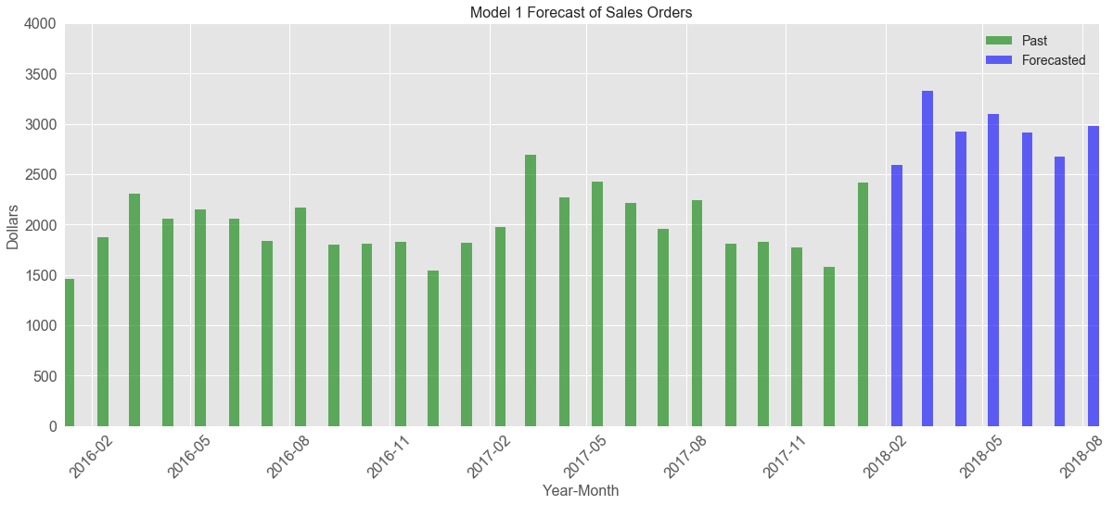

**Model 2:** Assumes January 2018 is an anomaly. Model excludes January 2018. Seasonal trend is present without positive growth.

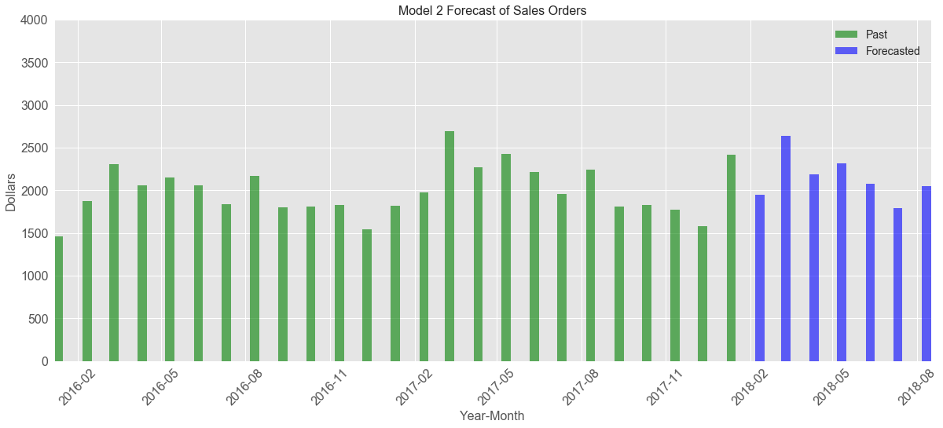

**Correct Models**

**Conclusion:** 2018 should more closely follow Model 1 than Model 2, indicating increased sales order growth for 2018.

**Model 1:** January 2018 is not anomaly. Model includes January 2018. Positive overall growth with strong seasonal trend.

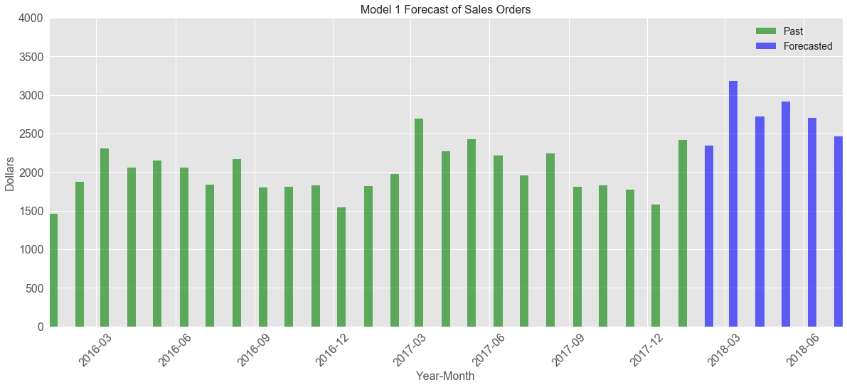

**Model 2:** Assumes January 2018 is an anomaly. Model excludes January 2018. Seasonal trend is present without positive growth.

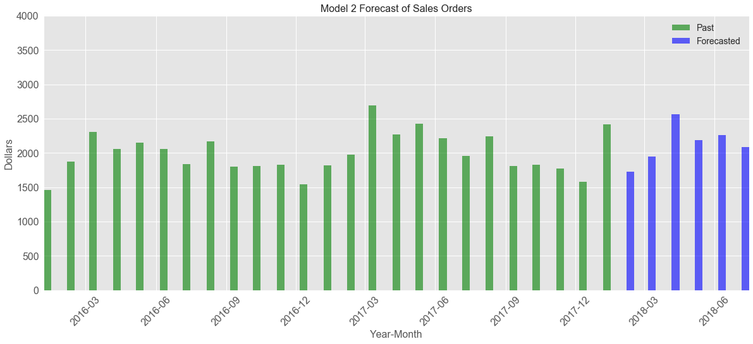

**Correct Models w/ Actual Order thru May 2018**

**Conclusion:** 2018 should more closely follow Model 1 than Model 2, indicating increased sales order growth for 2018.

**Model 1:** January 2018 is not anomaly. Model includes January 2018. Positive overall growth with strong seasonal trend.

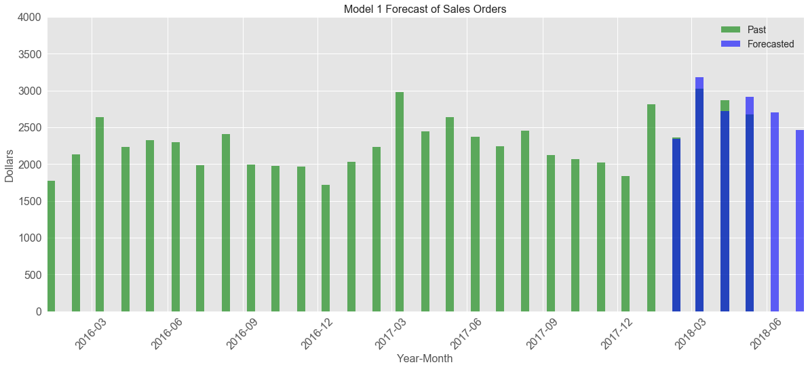

**Model 2:** Assumes January 2018 is an anomaly. Model excludes January 2018. Seasonal trend is present without positive growth.

